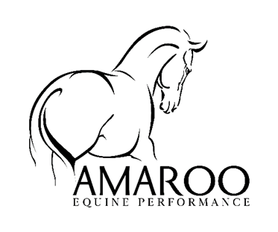

During Your Horse's Massage
- Upon meeting for your horse's initial consultation, we will discuss your horse's health, your training goals, and what you hope massage can do you for your horse. I will then conduct a series of static observations and dynamic assessments.
** If possible, I like to film your horse being hand-walked and trotted in order to note gait and movement patterns. Any photos or film taken of your horse are for my own personal review and will be deleted after evaluation.
- Your horse’s massage should take place in a location where he feels comfortable and secure, with as little distraction as possible. Loosely tied up or in cross ties are both good options. An additional handler is rarely necessary. Once the massage begins, you are welcome to stay and watch or attend to other business.
- A typical session includes a general full-body massage with special attention to any areas of concern. In addition to targeted manual techniques, you may also see me perform stretches and range of motion exercises. During your horse's session, I take note of findings throughout on your horse's chart.
- Please plan to allow approximately 45 minutes per massage,
Initial consultations often run longer.

- Horses' reactions to massage vary widely. Some are born knowing how to relax, many remain active participants throughout, and most fall somewhere in between. It is not uncommon for a horse to require three or more massages before the purpose of the bodywork seems to "click." Though relaxation is always a valuable product of massage, rest assured that the physiological benefits are no less great if your horse remains alert throughout his session.
- Payment is due at the time of service. Cash or Bank transfer (with receipt sent at time of massage) is gratefully accepted.

